Which of the following grammars describe the same language recognized by the NFA shown in Figure 1 below?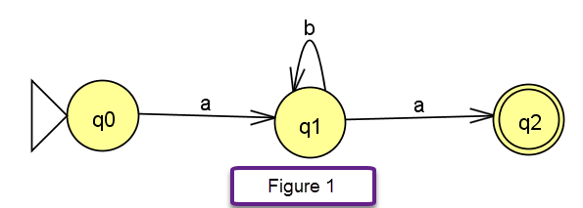

**S -> AB**

**A -> a**

**B -> bB | ^**

Which of the following are regular grammars? Select all that apply.

**S -> A | B | C**

**A -> aA | ^**

**B -> abc | aaabC**

**C -> ^**

**S -> A | B | C**

**A -> aA | a**

**B -> abc | aaabC**

**C -> cC | c**

Consider the following grammar:

S -> A | B

A -> abA | a

B -> Bab | b

Which of the following regular expressions describe the same language?

**(ab)*a + b(ab)\***

Which of the following grammars describe the following language: $\{ab^{n}cd^{n+2}e(ef)^{m} | n,m∈N\}$

**S -> ABCD**

**A -> a**

**B -> bBd | c**

**C -> dd**

**D -> Def | e**

What language does the grammar below describe?

S -> ABC

A -> aba | a

B -> bBc | ^

C -> dCe | D

D -> Dfg | ^